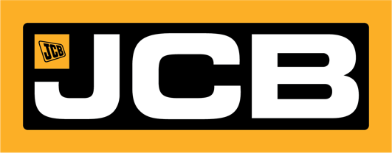
d

NEWS RELEASE

FOR IMMEDIATE RELEASE

JCB’S NEW USA PLANT TO DOUBLE IN SIZE IN WAKE OF TRUMP’S TARIFFS

Savannah, GA | April 3, 2025 - JCB is set to double the size of a new factory currently under construction in Texas as the company confirmed today that newly announced tariffs will impact its business in the short-term.

JCB has been manufacturing in the USA for 50 years, and last year bought 400 acres of land in San Antonio after recognizing the need to produce even more machines in North America, where the company’s existing manufacturing plant in Savannah, Georgia, has operated for 25 years and employs around 1,000 people.

The original plan for a 500,000 square feet factory in San Antonio has now been revised and JCB is forging ahead with plans to double its size to one million square feet. The new $500 million plant is due to start production next year and employ up to 1,500 people and will build on JCB’s growth in North America.

Today JCB Chairman Anthony Bamford said: “JCB has been in business for 80 years this year and we are well accustomed to change. The United States is the largest market for construction equipment in the world and President Trump has galvanized us into evaluating how we can make even more products in the USA, which has been an important market for JCB since we sold our first machine there in 1964.”

JCB CEO Graeme Macdonald said: “In the short term, the imposition of tariffs will have a significant impact on our business. However, in the medium term, our planned factory in San Antonio will help to mitigate the impact. We are thankful that the tariff is only 10% and we can only hope that the UK Government will conclude negotiations on a trade deal in the coming days and weeks.”

SOCIAL MEDIA:
YouTube – @JCBNorthAmerica https://www.youtube.com/@JCBNorthAmerica
Facebook CE – JCBNA https://www.facebook.com/jcbna/
Facebook AG – JCBAGNA https://www.facebook.com/jcbagna/
Instagram – JCBNA https://www.instagram.com/jcbna
X – @JCBna https://x.com/JCBna
LinkedIn – JCB North America https://www.linkedin.com/company/jcb-north-america
TikTok – @jcbna_ https://www.tiktok.com/@jcbna_

ABOUT JCB:
JCB is a family company founded on October 23, 1945, and is now one of the world’s largest privately owned manufacturers of construction, agricultural and defense equipment, with 22 factories around the world. JCB North America currently employs more than 1,000 people and operates out of its headquarters in Savannah, Georgia. JCB recently began work on a new $500 million factory in San Antonio, Texas, the biggest investment in its history. JCB’s North American division also has regional offices in San Antonio, Texas; Santa Monica, California; and Miami, Florida. JCB manufactures a range of more than 300 products for customers in 150 countries. JCB products include telescopic handlers, backhoe loaders, tracked and wheeled excavators, wheel loaders, compact excavators, skid steer loaders, compact track loaders, aerial work platforms, rough terrain forklifts, and Fastrac tractors. For more information, visit www.jcb.com.

###

MEDIA CONTACT:

Pam Veiock

JCB North America

Phone: 912-675-1434

Email: pam.veiock@jcb.com

Arielle Windham

Flint Group

Phone: 701-499-2169

Email: arielle.windham@flint-group.com

